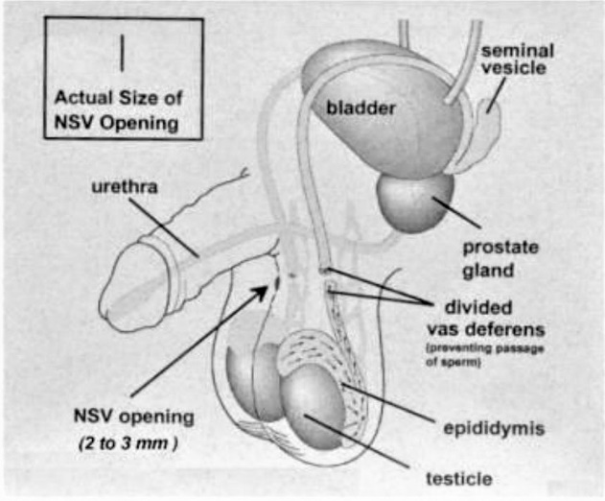
No Needle No Scalpel Vasectomy
Matthew L. Greenberger, M.D.
1801 N Broadway, Santa Ana CA 92706
OCurology.com 714-639-1915

Vasectomy is a permanent sterilization procedure for a man who is certain he would not like to father any more children. The procedure is performed in your urologist’s office. The vas deferens, the tube connecting the testicle to the urethra, is cut to prevent sperm from being added to the semen. Although a vasectomy can be reversed, it should be thought of a permanent sterilization procedure.

Risks of vasectomy

Bleeding: Bleeding into the scrotum is a serious complication, which can require surgery to correct. Following your doctor’s instructions will greatly reduce the risk of bleeding.

Infection: infection after vasectomy is rare, but is easily treated with antibiotics when necessary.

Failure of the procedure: Even when the vasectomy is performed in the usual manner, some patients will continue to have sperm in their semen after the procedure. YOU MUST CONTINUE TO USE OTHER BIRTH CONTROL METHODS UNTIL YOUR DOCTOR HAS TOLD YOU IT IS SAFE TO STOP. On rare occasions, sperm will find a way back into the semen even months or years after your vasectomy. It is possible to be fertile again if this happens.

POST VASECTOMY PAIN SYNDROME: A dull ache in the testicles is normal after your vasectomy. It usually lasts days or weeks. Far less than 1% of men have chronic heaviness or ache in the testicles after vasectomy.

Preparing for your vasectomy

Do not take aspirin or anti-inflammatory medications for one week before your vasectomy. They will increase the risk of bleeding. Examples of anti-inflammatory medications: Motrin, Advil, ibuprofen, Naprosyn, Aleve.
Do not drink alcohol the night before your vasectomy.

- Buy an athletic supporter (“jock strap”) that fits snugly. You will be asked to wear this for 72 hours after the vasectomy. The pressure will reduce the risk of bleeding. The support will make you more comfortable.
- Shower or bathe and wash your scrotum with soap and water the morning of your procedure.
- Please eat a light breakfast the morning of your procedure.

During your vasectomy
A local anesthetic will be given with a No Needle device. This area will be numb for 6 to 8 hours after the vasectomy. You will still feel the movement of your doctor during the procedure, but you will not feel pain in the area. If you do, tell the doctor, so he can give you more anesthetic.

After your vasectomy
- When you get home, wash off the surgical soap. If left on, it can irritate the skin.
- Wear the athletic supporter whenever possible for 72 hours.
- Keep an ice pack on your scrotum (over the top of the supporter) for 24 hours. Bags of frozen peas or corn are inexpensive and mold to the area well.
- Minimize your activity for 2 to 3 days. Stay home for 24 to 48 hours. No lifting more than 10 pounds, and avoid strenuous activity for one week.
- The skin opening(s) may ooze slightly, similar to a shaving cut on the face. Change the dressing at least daily until the oozing stops.
- BRUISING (black and blue or purple skin color) is common. If there is only bruising but minimal pain or swelling, do not worry about the skin color change
- You may have swelling of the scrotum, up to 50% larger than normal. A SUDDEN, DRAMATIC CHANGE IN SIZE CAN BE A SIGN OF BLEEDING OR INFECTION. Gradual changes that are equal on both sides are usually normal.

YOU MUST CONTINUE TO USE OTHER BIRTH CONTROL METHODS UNTIL YOUR DOCTOR TELLS YOU IT IS SAFE TO DISCONTINUE THEM.

Follow-up

About one to two months after your vasectomy, you must come back to the urologist to see how you are recovering, and to receive instructions for a semen analysis. Do not have a semen analysis until you have had at least 15 – 20 ejaculations after your vasectomy. Otherwise, sperm may still be present, even with a successful procedure.

Call our office a few days after the semen analysis so we can give you the results.
714-639-1915

CHECKLIST FOR THE DAY OF YOUR VASECTOMY

Bring a scrotal support or jock strap
Have ice packs (or frozen peas/corn) ready at home
If possible, arrange for a ride home
Don’t forget to fill the prescription for pain me

